HOSPITAL MANAGEMENT SYSTEM

AIM:
To Create a simple cloud software application for Hospital management
System using any Cloud Service Provider to demonstrate SaaS.

PROCEDURE:
step1: Go to zoho.com.
step 2: Log into the zoho.com.
step 3: Select one application step.
step4: Enter application name as Hospital management System.
step 5: Created new application as Hospital management System.
step 6: Select one form
step 7: The software has been created.

IMPLEMENTATION: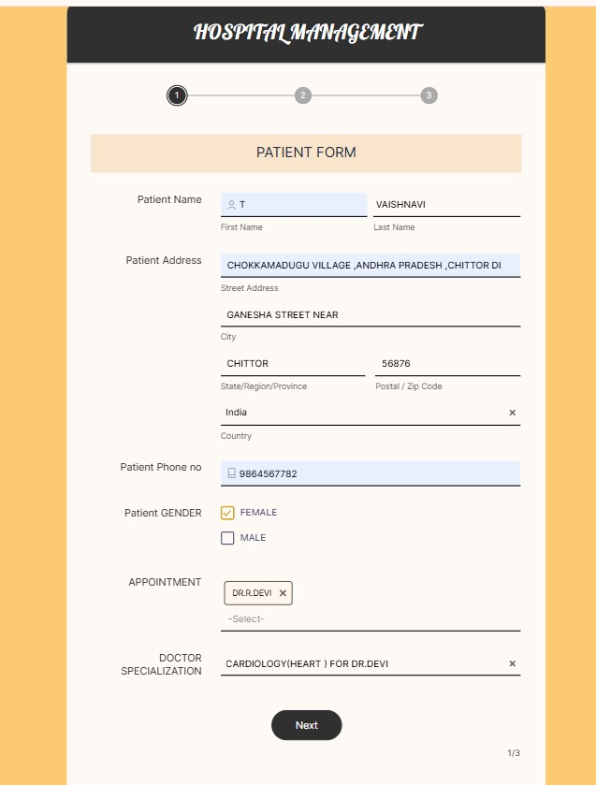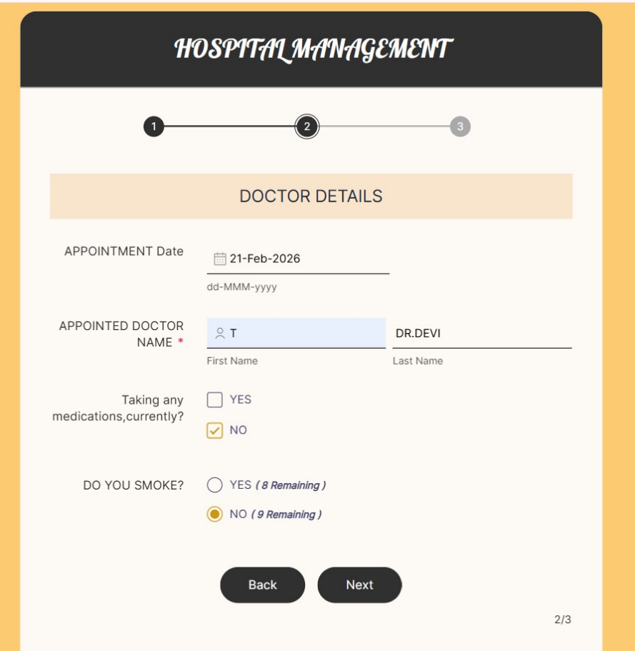

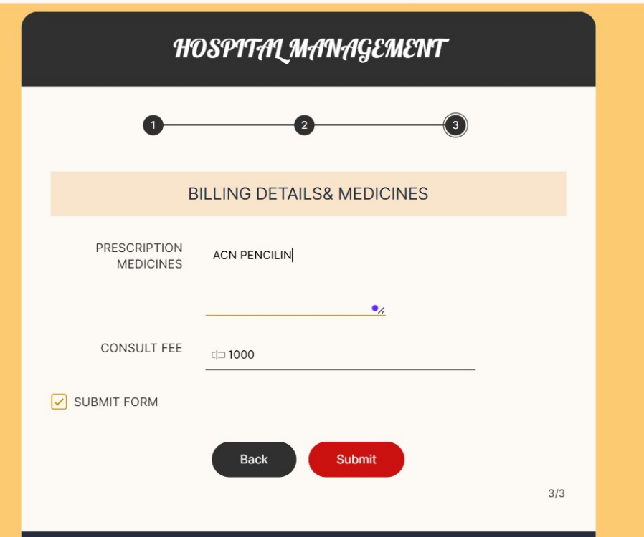

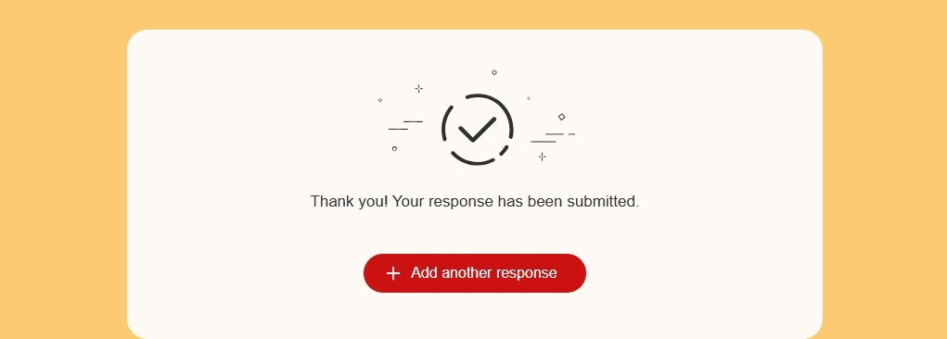

RESULT:
- The Hospital Management System was successfully developed and deployed on a cloud platform.
- The system allows users to:
  - Register patient details
  - Manage doctor information and appointments
  - Store and retrieve medical records securely
- All hospital data is stored in the cloud database, ensuring reliability and availability.
- The application can be accessed through a web browser from any location with internet connectivity.
- No local installation or maintenance is required by the users.
📌 Thus, the Hospital Management System successfully demonstrates the Software as a Service (SaaS) model.

